
SHIRE HIGHLANDS EDUCATION DIVISION
2025 MALAWI SCHOOL CERTIFICATE OF EDUCATION MOCK
EXAMINATION

PHYSICS
Subject Number: M164/II
Monday, 7th April, Time Allowed: 2 hour session
10:00 am onwards
PAPER II
Practical
(40 Marks)

Question  Number | Tick if  answered | Do not write in  these columns |  | Marker’s  Name
1
2
3
4
Instructions
- This paper contains 6 printed pages. Please check.

- This paper contains two sections, A and B.

- In section A, there are two descriptive questions on practical work to be answered in one hour. Marks will be given for accurate and orderly presentation of facts supported by relevant diagrams

- In section B there are two practical questions to be answered in one hour

- You should spend 30 minutes on each question in section A. The 30 minutes period allowed for each question include 3 minutes of tidy up apparatus and have it checked by the subject teacher.

$C$ 2025 SHED Turn over
SECTION A (20 Marks)
- Describe an experiment that can be done to verify the principle of moments.

________________________________________________________________________________________________________________________________________________________________________________________________________________________________________________________________________________________________________________________________________________________________________________________________________________________________________________________________________________________________________________________________________________________________________________________________________________________________________________________________________________________________________________________________________________________________________________________________________________________________________________________________________________________________________________________________________________________________________________________________________________________________________________________________________________________________________________________________________________________________________________________________________________________________________________________________________________________________________________________________
- arks)
- A student investigated whether different liquids have different densities. The student recorded data as shown below:
Liquid | Volume (cm³) | Mass (g) | Density
A | 10 | 10
B | 10 | 8
Write a laboratory report on this investigation. In the report, include the title for the report, aim of the experiment, apparatus used, procedure followed, analysis of data collected and conclusion.

________________________________________________________________________________________________________________________________________________________________________________________________________________________________________________________________________________________________________________________________________________________________________________________________________________________________________________________________________________________________________________________________________________________________________________________________________________________________________________________________________________________________________________________________________________________________________________________________________________________________________________________________________________________________________________
(10 marks)
SECTION B (20 Marks)
- You are provided with an insulated copper wire, soft iron nail, 4 cells in cell holders, switch, ammeter, 4 connecting wires and 6 steel money clips.
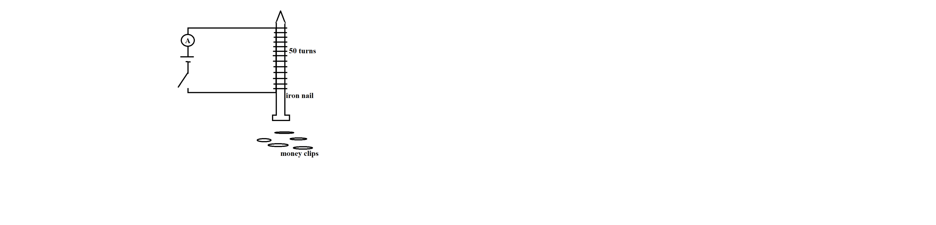
- Set up the apparatus as shown in Figure 1 below.

Figure 1
- Close the switch and record the ammeter reading in the Table 1.
- Place the money clips at the base of the nail one after the other and record the maximum number of money clips the electromagnet can keep attracted to it.
- Repeat the experiment by increasing the number of cells as shown in Table 1.
Table 1
Number of cells | Current (A) | Number of pins collected
1
2
3
4

(4 marks)

- Plot a graph of number of pins collected against current. (4 marks)

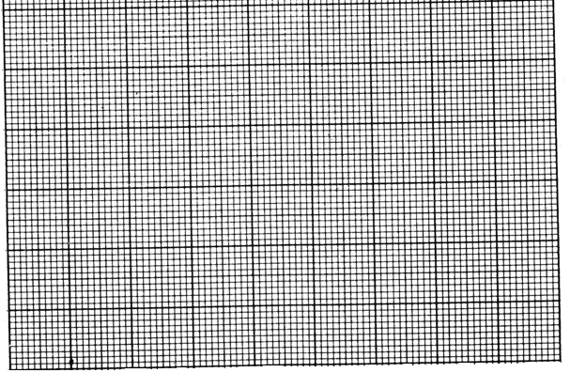

- Using the graph, what is the relationship between amount of current and the number of money clips picked?
___________________________________________________________________________
(1 mark)
g. What conclusion can be drawn from this experiment?
___________________________________________________________________________
- mark)
- You are provided with a spiral spring, 200 g mass, 30cm ruler and a stand.
a. Arrange the apparatus as shown in Figure 2.
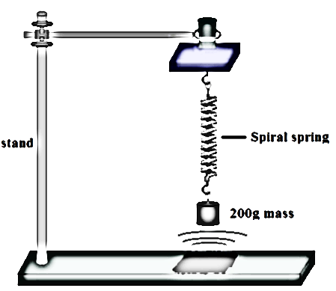
Figure 2
b. Pull the mass down to amplitude of 3 cm.
c. Allow the spiral spring to oscillate freely.
d. Record time taken for 10 complete oscillations.
e. Repeat steps b - d using amplitudes of 4cm, 5cm and 6 cm respectively.
Table 2
Amplitude (cm) | Time taken for 10 complete oscillations (s) | Frequency ( $\frac{Number of complete oscillations}{time})$
3
4
5
(6 marks)
f. Calculate frequency for each amplitude and fill in Table 2 under the frequency column.
g. From the Table 2 , state the relationship between amplitude of an oscillating system and its
frequency.
______________________________________________________________________________________________________________________________________________(1 mark)
h. What is the aim of the experiment? ______________________________________________________________________________________________________________________________________________(1 mark)
i. What conclusion can be drawn from the experiment?
______________________________________________________________________________________________________________________________________________(1 mark)
j. State any one source of error in the experiment?
______________________________________________________________________________________________________________________________________________(1 mark)

END OF QUESTION PAPER

NB: This paper contains 6 printed pages.

